Name of operator:
Workstation Location/Number: |  |  | Date:
Person carrying out assessment:

- Keyboard
Assessment Criteria | Yes | No | Comments
Is the keyboard separate from the screen?
This is a requirement unless the task makes it impracticable e.g., where there is a need to use a portable.
Can the keyboard be tilted to allow the operator to find a comfortable position?
Tilt need not be built in.
Is there space on the table to allow the operator to rest their arms?
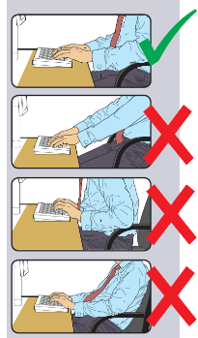

Try pushing the display screen further back to create more room for the keyboard, hands and wrist.

Users of thick, raised keyboards may need a wrist rest.
Does the user have good keyboard technique?
Training can be used to prevent:
- Hands bent up at the wrist.
- Hitting the keys too hard.
- Overstretching the fingers.
Is there a matt surface to avoid glare?
Use a keyboard with a matt finish to reduce glare and/or reflection.
Are characters on the keys easily legible?
Keyboards should be kept clean. If characters still can’t be read, the keyboard may need modifying or replacing.
Is the keyboard easy to use?

- Mouse/Tracker Ball
Assessment Criteria | Yes | No | Comments
Is the device positioned close to the user?
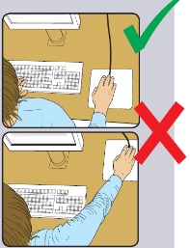

Most devices are best placed as close as possible e.g., right beside the keyboard.
Training may be needed to
- Prevent arm overreaching.
- Encourage users not to leave their hand on the device when it is not being used.
- Encourage a relaxed arm and straight wrist.
Is the device suitable for the tasks it is used for?
If the user is having problems, try a different device. The mouse and trackball are general-purpose devices suitable for many tasks, and available in a variety of shapes and sizes. Alternative devices such as touch screens may be better for some tasks but can be worse for others.
Is there support for the user’s wrist and forearm?
Support can be gained from, e.g., the desk surface or arm of a chair. If not, a separate supporting device may help.
The user should be able to find a comfortable working position with the device.
Does the device work smoothly at a speed that suits the user?
See if cleaning is required e.g., of mouse ball and rollers. Check the work surface is suitable. A mouse mat may be needed.
Can the user easily adjust software settings for speed and accuracy of pointer?
Users may need training in how to adjust device settings.

- Display Screen Equipment
Assessment Criteria | Yes | No | Comments
Are the characters clear and readable?

The Health & Safety Service Ltd
The Health & Safety Service Ltd

Make sure the screen is clean and cleaning materials are available.
Check that the text and background colours work well together.
Is the text size comfortable to read?
Software settings may need adjusting to change text size.
Does the screen swivel and tilt easily, to allow optimum positioning?

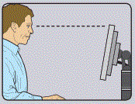

Swivel and tilt need not be built in, you can add a swivel and tilt mechanism.
However, you may need to replace the screen if:
- swivel/tilt is absent or unsatisfactory.
- work is intensive; and/or
- the user has problems getting the screen to a comfortable position.
Is the screen free from reflections and glare?
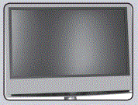

Use a mirror placed in front of the screen to check where reflections are coming from. You might need to move the screen or even the desk and/or shield the screen from the source of the reflections. Screens that use dark characters on a light background are less prone to glare and reflections.
Are the brightness and contrast controls easily adjustable?
Separate adjustment controls are not essential, provided the user can always read the screen easily.

- Display Screen Equipment continued
Assessment Criteria | Yes | No | Comments
Is the screen image stable and flicker-free?
Try using different screen colours to
reduce flicker, e.g., darker background and lighter text. If there are still problems, get the set-up checked, e.g., by the equipment supplier.
Is the screen’s specification suitable for its intended use?
For example, intensive graphic work or work requiring fine attention to small details may require large display screens.
Are characters well defined on the screen with adequate spacing?
Are adjustable window coverings provided and in adequate condition?
Check that blinds work. Blinds with vertical slats can be more suitable than horizontal ones. If these measures do not work, consider anti-glare screen filters as a last resort and seek specialist help.

- Work Surface or Table
Assessment Criteria | Yes | No | Comments
Is the table a suitable size to allow for positioning of equipment?
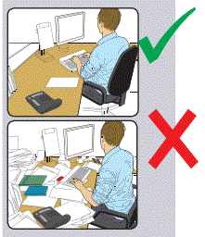

Create more room by moving printers, reference materials etc elsewhere. If necessary, consider providing new power and telecoms sockets, so equipment can be moved. There should be some scope for flexible rearrangement.
Can the user comfortably reach all the equipment and papers they need to use?
Rearrange equipment, papers etc. to bring frequently used things within easy reach. A document holder may be needed, positioned to minimise uncomfortable head and eye movements.
Is the surface free from glare or reflection?
Consider mats or blotters to reduce reflections and glare.

- Chair
Assessment Criteria | Yes | No | Comments
Is the chair suitable?
Is the chair stable?
The chair may need repairing or replacing if the user is uncomfortable or cannot use the adjustment mechanisms.
Is the chair adjusted correctly?

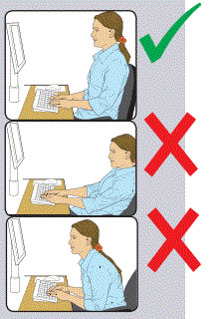
The user should be able to carry out their work sitting comfortably. Consider training the user in how to adopt suitable postures while working. The arms of chairs can stop the user getting close enough to use the equipment comfortably. Move any obstructions from under the desk.
Is the small of the back supported by the chair’s backrest?
The user should have a straight back, supported by the chair, with relaxed shoulders.
Are feet flat on the floor, without too much pressure from the seat on the backs of the legs?
If not, a footrest may be needed.
Are forearms horizontal and eyes at roughly the same height as the top of the DSE?
Adjust the chair height to get the user’s arms in the right position, and then adjust the DSE height, if necessary.
If the chair has arms, can it be moved close to the desk?

- Environment
Assessment Criteria | Yes | No | Comments
Is there enough room to change position and vary movement?
Space is needed to move, stretch and fidget. Consider reorganising the office layout and check for obstructions. Cables should be tidy and not a trip or snag hazard.
Is the lighting suitable, e.g., not too bright or too dim to work comfortably?
Users should be able to control light levels, e.g., by adjusting window blinds or light switches. Consider shading or repositioning light sources or providing local lighting, e.g., desk lamps (but make sure lights do not cause glare by reflecting off walls or other surfaces).
Are windows fitted with blinds to prevent glare where necessary?
Are levels of noise comfortable?
Consider moving sources of noise, e.g., printers, away from the user. If not, consider soundproofing.
Are levels of heat comfortable?
Can heating be better controlled? More ventilation or air conditioning may be required if there is a lot of electronic equipment in the room. Or can users be moved away from the heat source?
Is local heating provided as necessary?
Does the air feel comfortable?
DSE and other equipment may dry the air. Circulate fresh air if possible. Plants may help. Consider a humidifier if discomfort is severe.

- Operator and Computer interface
Assessment Criteria | Yes | No | Comments
Is the software suitable for the task?
Software should help the user carry out the task, minimise stress and be user-friendly. Check users have had appropriate training in using the software. Software should respond quickly and clearly to user input, with adequate feedback, such as clear help messages.
Is the software easy to use and understand?
Does the system provide feedback such as error messages and help screens?
Does the system provide feedback in a fashion that is suitable for the operator such as the display of characters as they are typed?
Does the system monitor the quality or quantity of operator input?

- Overall Management
Assessment Criteria | Yes | No | Comments
Is work on DSE regularly interrupted by other activities or breaks?
Is information given on the availability of eye tests?
Are spectacles provided where necessary?
Are there any complaints regarding work equipment or the working environment?
Are sickness rates higher than normal?
Are operators trained in the use of the workstation?
Is information provided in relation to the health and safety of the workstation?
Do operators know how to report defects?
Are people trained to recognise the symptoms of DSE-related illnesses?
Have any complaints been received concerning visual fatigue, aches etc.?
Has the operator been trained in the correct use of the mouse, to avoid the possibility of aches and pains occurring?

Comments by person using the workstation (optional)

Assessors Comments

Problems identified from sheets 1 & 2

Current Control Measures

Further Control Measures required
Action required | Target date | Action by | Date completed | Signature

Is Health Surveillance required - If yes please state why? | Yes | No

Next review date of assessment:

Line Managers Comments:

Name: | Signature: | Date:

Review
Date | Comment | Action completed by

